# VPC-Peering

A VPC peering connection is a networking connection between two VPCs that enables you to route traffic between them using private IPv4 addresses or IPv6 addresses.

* You can create a VPC peering connection between your own VPCs, or with a VPC in another AWS account.
* The VPCs can be in different Regions (also known as an inter-Region VPC peering connection).

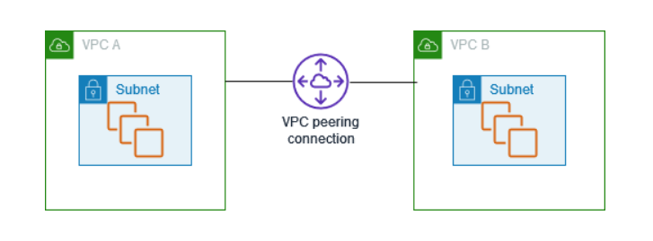

AWS uses the existing infrastructure of a VPC to create a VPC peering connection; it is neither a gateway nor a VPN connection, and does not rely on a separate piece of physical hardware.

A VPC peering connection helps you to facilitate the transfer of data. For example, if you have more than one AWS account, you can peer the VPCs across those accounts to create a file sharing network. You can also use a VPC peering connection to allow other VPCs to access resources you have in one of your VPCs.

The traffic remains in the private IP space. All inter-Region traffic is encrypted with no single point of failure, or bandwidth bottleneck

# 

VPC peering scenarios

## Peering two or more VPCs to provide full access to resources

## Peering to one VPC to access centralized resources

## [Peering with ClassicLink](https://docs.aws.amazon.com/vpc/latest/peering/peering-scenarios.html#peering-scenarios-classiclink)